DIGITAL BULLETIN BOARD
@CREATIVITY THINK (9483175986/7019689991)

ABSTRACT:
The Digital Bulletin Board is a web-based system designed to streamline communication within societies, clubs, and offices. It enables users to post messages and announcements, while administrators can approve, expire, or moderate content and monitor analytics through a dashboard. The platform also supports comments, alerts, and tracking of active and expired posts. Built using Django and Django Rest Framework for backend processing and React with Redux and recharts for frontend interaction, the system ensures a secure, efficient, and organized communication flow. It enhances community engagement, reduces manual notice management, and provides administrators with comprehensive operational insights..

INTRODUCTION OF THE PROJECT:
Traditional bulletin boards and notice management methods are often physical, unorganized, or scattered across emails and chat platforms. These approaches lack approval workflows, analytics, and content lifecycle management, leading to missed announcements and communication gaps. The Digital Bulletin Board addresses these challenges by providing a centralized platform for posting, approving, expiring, and tracking messages. Users can interact with posts through comments, while administrators maintain control over content, ensure timely dissemination, and gain insights from dashboards. This system improves transparency, organization, and overall communication efficiency..

PROJECT OBJECTIVES:

• Provide a digital platform for posting announcements and messages
• Implement approval workflows for administrators
• Track message lifecycle including expiry and alerts
• Allow users to comment on messages
• Offer dashboards with analytics on posts and user engagement
• Support structured notifications and alert systems
• Ensure secure and permission-based access to content
• Provide scalable and maintainable backend services

PROBLEM OF THE STATEMENT:
Organizations and communities frequently rely on physical notice boards or unstructured digital platforms to communicate announcements. These methods often result in delayed dissemination, missing information, unapproved content, and lack of analytics. Administrators cannot track engagement, and users may miss critical messages. The Digital Bulletin Board addresses these issues by providing a centralized system with approval controls, automated expirations, notifications, and dashboards for effective management and improved communication flow..

MOTIVATION OF THE PROJECT:
• To digitize and streamline announcement management
• To reduce communication delays and errors
• To provide structured workflows for approval and expiration of messages
• To enhance community engagement through comments and alerts
• To provide administrators with actionable insights through dashboards
• To ensure secure and organized management of digital notices
• To improve overall transparency and accountability in communications

BLOCK DAIGRAM OF PROJECT:

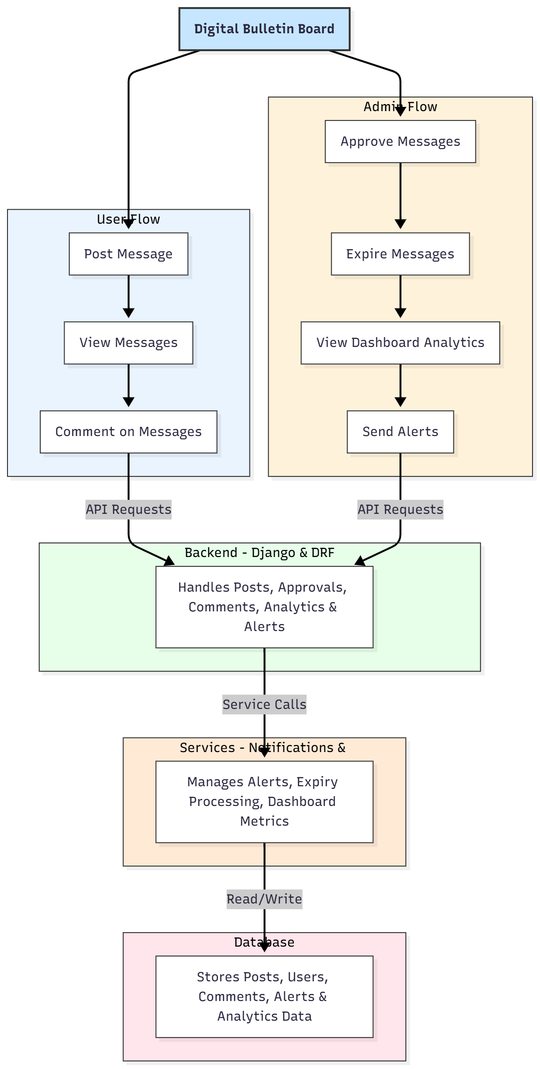

WORKING OF THE PROJECT:
Users can create and post messages through the frontend interface. Submitted messages are sent to the backend where they await administrative approval. Once approved, messages appear on the bulletin board for all users to view. Users can comment on posts, and administrators can expire old messages automatically or manually. Notifications and alerts inform users of critical updates. The dashboard provides analytics on post engagement, approvals, and expiry rates. All data, including posts, comments, alerts, and user activity, is securely stored in the database. Backend services handle approvals, alerts, analytics computations, and expiry processing, ensuring a seamless communication workflow..

SOFTWARE REQUIREMENT:
- Backend:
  - Python 3.x
  - Django
  - Django REST Framework
  - SQLite/PostgreSQL
- Frontend:
  - Node.js and npm
  - React.js
  - Axios
- Development Tools:
  - Visual Studio Code
  - Postman (for testing APIs)
  - Git/GitHub (for version control)
- Server/Deployment (Optional):
  - Gunicorn, Nginx, or Heroku/AWS for hosting

ADVANTAGES OF THE PROJECT:

• Centralized and organized communication platform
• Approval workflows for controlled content posting
• Automated message expiry and alert notifications
• Dashboard analytics for engagement insights
• User interaction through comments
• Reduces missed announcements and communication delays
• Secure and permission-based access
• Enhances accountability and transparency in organizations

APPLICATIONS OF THE PROJECT:
• Residential societies and apartments
• Clubs and associations
• Corporate offices
• Schools and universities
• Community organizations
• Event and activity management

REFERENCES:

- Django REST Framework Documentation — Django Software Foundation. Django Documentation. Available: https://docs.djangoproject.com/
- Django REST Framework. DRF Documentation. Available: https://www.django-rest-framework.org/
- React. React Official Documentation. Available: https://reactjs.org/docs/getting-started.html
- Redux. Redux Documentation. Available: https://redux.js.org/introduction/getting-started
- PostgreSQL Global Development Group. PostgreSQL Documentation. Available: https://www.postgresql.org/docs/
- MySQL. MySQL Reference Manual. Available: https://dev.mysql.com/doc/
- Git. Git Documentation. Available: https://git-scm.com/doc
- Node.js. Node.js Documentation. Available: https://nodejs.org/en/docs/
- Axios. Axios Documentation. Available: https://axios-http.com/docs/intro
- Socket.io Documentation – https://socket.io/docs/

